CSA0713 -COMPUTER NETWORKS

FOR HOME AUTOMATION

G.JANANI

192211050

Course Faculty: Dr.Serban Obreja

Supervisor: Dr.Navaprakash

Assignment -1

1. Implement the network topology given in the figure. Configure the default gateway on the computer machines. Insert a static route on r1 with the route to network C (collision domain C). Insert a static route on r2 with the route to network A (collision domain A).

Step-1: Create directory called lab1

Step-2:Change directory

Step-3:Make directory according to the given fig

Step-4:Open Notepad

Step-5:Give IP Address and router

Step-6:Save content Written in Notepad

Step-7:In Windows Power Shell,ctrl S - dir

Step-8:kathara lstart

Step-9:root pages will open

Step-10:Ping address which you want ping from where to destination.

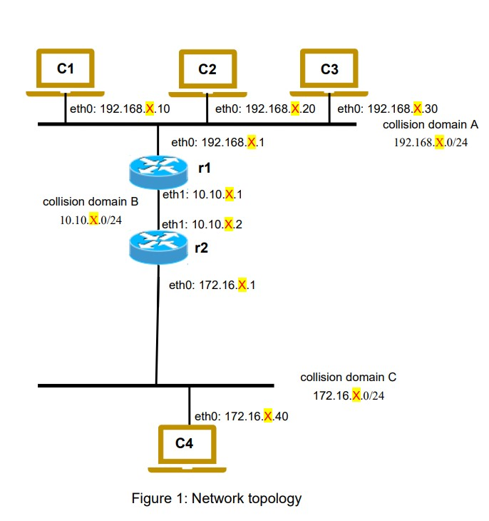

1. Creating lab topology

• Create the file named lab1.

• Create intermediate file named lab.conf.

• Content of the lab.conf as follows.

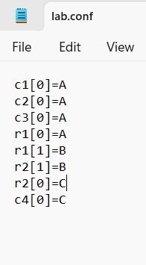

1. Startup files Creating

• Create startup files for each device.

• Name of the file shold be the file extension(.startup) followed by the device name (eg: c1.startup).

1. Contents of startup files

• The content of startup file for each device is their respective IP configurations,interface,netmask and routing address.

➢ c1.startup

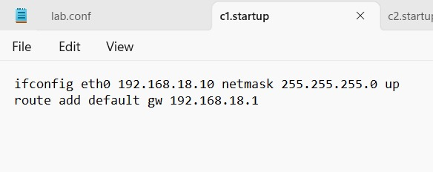

➢ c2.startup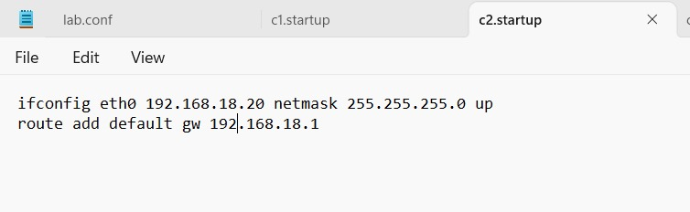

➢ c3.startup

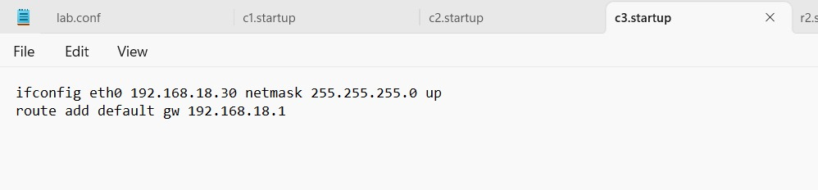

➢ c4.startup

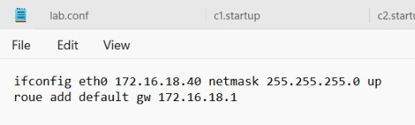

➢ r1.startup_____________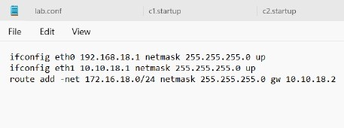

➢ r2.startup_________________

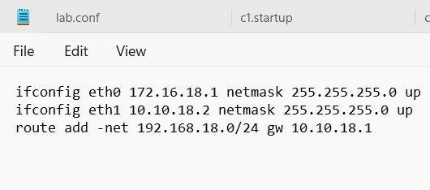

1. Implementing

• To implement the network topology open docker and run in background.

• Now,open windows power shell and change directory(cd) to

Lab1

• Then start kathara application by using (kathara lstart).

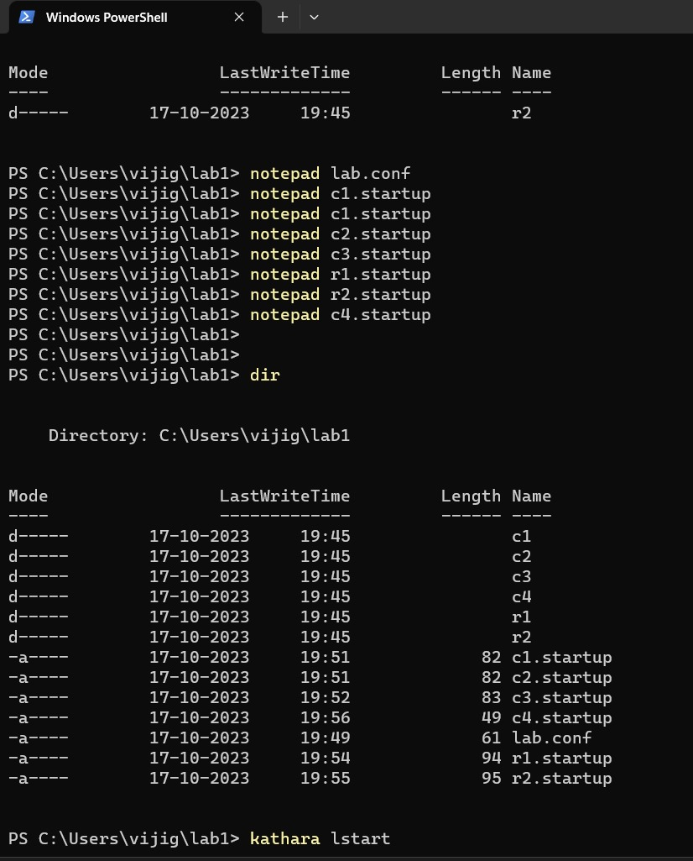

1. Observation

• Capture the packet with the ping command

• Check whether the ping is working or not.

• Capture with the tcpdump command on the interface eth0. Started on r2,while the ping from c2 to c4 is working.

c2 to c4

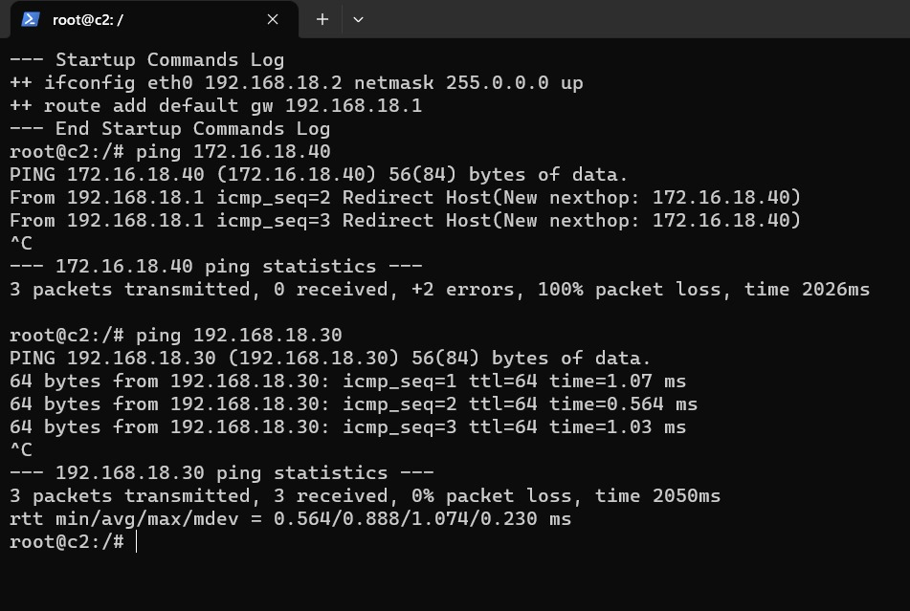

c1 to c2

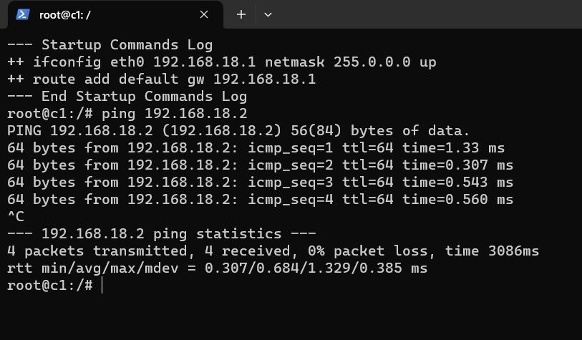

1. Routing tables

• To verify the routing table use command route for the given routers (ie: r1 and r2).

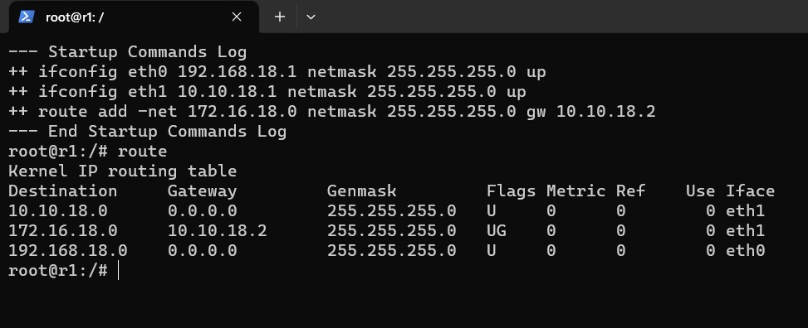

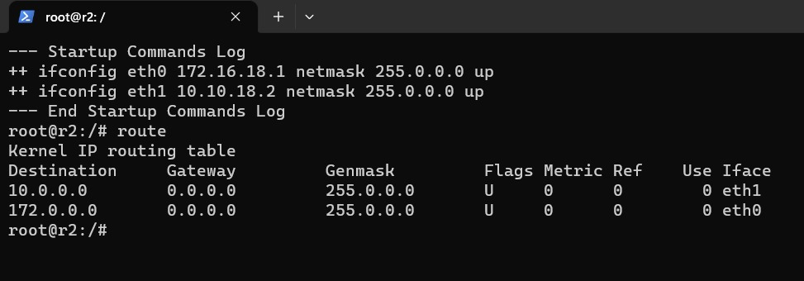

1. Stopping kathara

• To stop kathara after completion of network topology verification, use the command kathara lclean to clear all network collision domains and devices.

